IM343AI
USN

RV COLLEGE OF ENGINEERING®
Autonomous Institution affiliated to VTU
IV Semester B. E. Sept / Oct 2024 Examinations
DEPARTMENT OF INDUSTRIAL ENGINEERING AND MANAGEMENT
MODEL QUESTION PAPER
CAD/CAM AND ROBOTICS
(2022 SCHEME)

Time: 03 Hours Maximum Marks: 100
Instructions to candidates:
- Answer all questions from Part A. Part A questions should be answered in first three pages of the answer book only.
- Answer FIVE full questions from Part B. In Part B question number 2 is compulsory. Answer any one full question from 3 and 4, 5 and 6, 7 and 8 and 9 and 10.

PART – A (Objective type for one or two marks)
(True & false and match the following questions are not permitted)
1 | Answer all questions |  |  |  |  | Marks | BT | CO
 | 1.1 |  |  |  | The process of originating and developing a plan for a product, structure, system or component is known as ______________. | 1 | 1 | 1
 | 1.2 |  |  |  | Two or more processing (or assembly) operations are being performed ___________on the same workpart, thus reducing total processing time. | 1 | 2 | 2
 | 1.3 |  |  |  | DDA stands for __ | 1 | 1 | 3
 | 1.4 |  |  |  | The process of positioning an object along a straight line path from one coordinate point to another is called __ | 1 | 2 | 2
 | 1.5 |  |  |  | In a CNC program block, N002 G02 G91 X40..., GO2 refer to___ | 1 | 2 | 1
 | 1.6 |  |  |  | _______is a technology concerned with the application of mechanical, electronic, and computer-based systems to operate and control production | 1 | 1 | 2
 | 1.7 |  |  |  | A __________ automated system is one that is capable of producing a variety of products (or parts) with virtually no time lost for changeovers from one product to the next | 1 | 2 | 1
 | 1.8 |  |  |  | The information-processing cycle, represented by the outer ring, can be described as consisting of four functions they are Business functions, Product design, Manufacturing planning and ________ | 1 | 1 | 4
 | 1.9 |  |  |  | The common robotic arm has _______ degrees of freedom. | 1 | 1 | 2
 | 1.10 |  |  |  | Devices which reduce the amount of interference in signals are called _____ | 1 | 1 | 3
 | 1.11 |  |  |  | Why is the complexity of Bresenham's line drawing algorithm less than that of DDA line drawing algorithm? | 2 | 1 | 2
 | 1.12 |  |  |  | List the types of Computer graphics. | 2 | 3 | 3
 | 1.13 |  |  |  | In CAD package, mirror image of a 2D point P(5,10)is to be obtained about a line which passes through the origin and makes an angle of 45⁰ counterclockwise with the X-axis the coordinates of the transformed point will be _____ | 2 | 2 | 2
 | 1.14 |  |  |  | State the Zeroth Law of robotics. | 2 | 2 | 4
 | 1.15 |  |  |  | What is meant by robot anatomy? | 2 | 2 | 4
PART – B (Maximum subdivision is limited to 4 in each question)
UNIT – I
2 |  | a |  |  | The process of designing something is characterized by Shigley as an interactive procedure which consists of six identifiable steps. Elaborate the steps with block diagram. | 08 | 2 | 1
 |  | b |  |  | Express a line from (2, 3) to (6, 15) on a raster screen using Bresenham’s Line Drawing Algorithm. Show the result in a Cartesian graph. | 08 | 1 | 1
UNIT – II
3 |  |  | a |  | Discuss the various elements of a typical Numerical Control system | 06 | 1 | 2
 |  |  | b |  | Write a CNC turning program for the given profile. The cutting tool used is Left hand tool.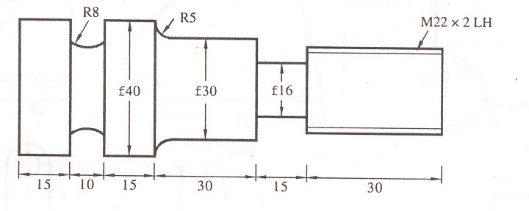 | 10 | 3 | 2
OR
4 |  |  | a |  | Explain with the help of an example  - Linear interpolation  - Circular interpolation | 08 | 2 | 2
 |  |  | b |  | Write a CNC milling program for the given profile. The cutting tool used is slot drill cutter and the depth of cut is 5mm.  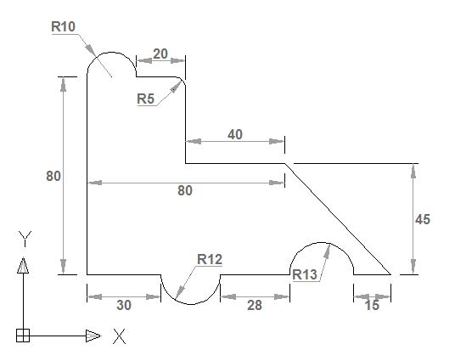 | 08 | 3 | 2
UNIT - III
5 |  |  | a |  | Identify major socio-economic considerations favoring automation | 08 | 2 | 3
 |  |  | b |  | With example state the difference between mechanization and automation | 08 | 1 | 3
OR
6 |  |  | a |  | List and explain Automation Strategies that are employed to improve productivity in manufacturing operations | 08 | 2 | 3
 |  |  | b |  | Explain how low cost automation is useful in manufacturing industry | 08 | 2 | 3
UNIT - IV
7 |  |  | a |  | What are the various types of joints used in robots? Sketch the following robots indicating the joints and degree of freedom.  i) SCARA Robot. ii) Articulated Robot. | 08 | 2 | 4
 |  |  | b |  | Compare the various attributes of robot with those of human being. Explain a robot structure with a sketch | 08 | 1 | 4
OR
8 |  |  | a |  | Explain the selection criteria to select one among the different Robot. | 08 | 1 | 4
 |  |  | b |  | Classify robots based on their power source. Explain the application pertaining to each class. | 08 | 2 | 4
UNIT - V
9 |  |  | a |  | What are the different types of sensors? Classify them. Sketch and explain the use of a velocity sensor. | 08 | 2 | 4
 |  |  | b |  | Explain the working principle of an end effector with the help of a sketch and give its important applications. | 08 | 1 | 4
OR
10 |  |  |  | a | Explain the principle of the following sensors and also mention how they are used in robots. (i) Piezo electric sensor (ii) Tactile sensor | 08 | 2 | 4
 |  |  |  | b | Discuss the lead through programming technique used in robot programming | 08 | 2 | 4

……… ……….. ………………………Q.P.Code (For office use only)
UG

Course Code: IM343AI | Course Title: CAD/CAM AND ROBOTICS

PART-A
Q.No | 1.1 | 1.2 | 1.3 | 1.4 | 1.5 | 1.6 | 1.7 | 1.8 | 1.9 | 1.10
B T | 1 | 2 | 1 | 2 | 21 | 2 | 1 | 2 | 1 | 1
COs | 1 | 2 | 3 | 2 | 1 | 2 | 1 | 4 | 2 | 3
Q No | 1.11 | 1.12 | 1.13 | 1.14 | 1.15 | 1.16 | 1.17 | 1.18 | 1.19 | 1.20
B T | 1 | 1 | 3 | 2 | 2
COs | 2 | 3 | 2 | 4 | 4

PART-B
Question  No |  | B T  Levels | Cos addressed |  | Question No |  | BT  Levels | Cos addressed
2 | a | 2 | 1 |  | 3 | a | 1 | 2
2 | b | 1 | 1 |  | 3 | b | 3 | 2
2 | c |  |  |  | 3 | c
2 | d |  |  |  | 3 | d
4 | a | 1 | 2 |  | 5 | a | 2 | 3
4 | b | 3 | 2 |  | 5 | b | 1 | 3
4 | c |  |  |  | 5 | c
4 | d |  |  |  | 5 | d
6 | a | 2 | 3 |  | 7 | a | 2 | 4
6 | b | 2 | 3 |  | 7 | b | 1 | 4
6 | c |  |  |  | 7 | c
6 | d |  |  |  | 7 | d
8 | a | 1 | 4 |  | 9 | a | 2 | 4
8 | b | 2 | 4 |  | 9 | b | 1 | 4
8 | c |  |  |  | 9 | c
8 | d |  |  |  | 9 | d
10 | a | 2 | 4 |  | 11 | a
10 | b | 2 | 4 |  | 11 | b
10 | c |  |  |  | 11 | c
10 | d |  |  |  | 11 | d

Signature of Scrutinizer: Signature of Chairman

Name: Name:

